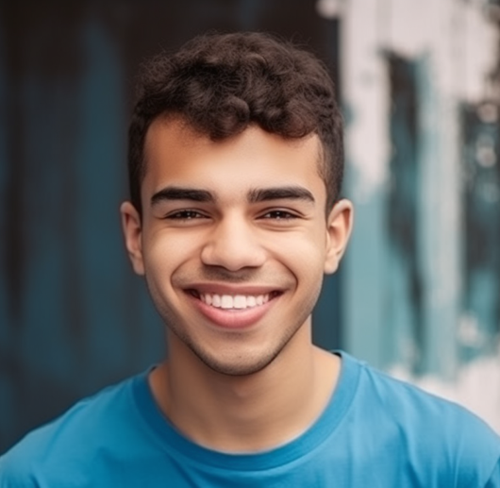 | DANIEL FOSTER  Professional Waiter  Reliable, energetic, and detail-oriented professional with over 6 years of extensive hospitality experience in diverse dining environments. Recognized for delivering consistent service excellence, enhancing guest satisfaction.
daniel.foster@email.com ￭ (415) 987 6543 ￭ Los Angeles, CA ￭ linkedin.com/in/danielfoster ￭ danielfoster.wa

Work Experience  Senior Waiter  Seaside Grill & Lounge  01/2019 – Present ￭ Los Angeles, CA  - Provide professional table service to an average of 120 guests daily, ensuring a smooth and welcoming dining experience.  - Train and mentor 10+ new waiters in guest interaction, safety procedures, and menu knowledge.  - Maintain adherence to sanitation and hygiene regulations, ensuring compliance with health and safety standards.  Waiter & Host  Golden Spoon Bistro  06/2015 – 12/2018 • Los Angeles, CA  - Delivered courteous guest service by welcoming patrons, managing reservations, and offering personalized food recommendations.  - Assisted in the development of seasonal menu promotions, contributing to a 17% increase in average monthly sales.  - Trained 6 newly recruited staff in customer service  etiquette and order-handling procedures.  Customer Service Assistant  Urban Eats Café  05/2013 – 05/2015 • Los Angeles, CA  - Assisted in preparing and serving meals while ensuring high standards of hygiene and quality.  - Built strong customer relationships by addressing special dietary requests and ensuring satisfaction.  Education  High School Diploma  Jefferson High School  Graduated: 2013 |  |  | Skills and Competencies  - Customer Service Excellence  - Food & Beverage Knowledge  - Time Management  - Team Collaboration  - Hygiene & Food Safety  - Upselling Techniques  - Problem-Solving  - Multitasking  Courses & Training  Advanced Waiter & Hospitality Training – Hospitality Institute (2016)  Food Hygiene & Safety Certification – ServSafe (2015)  Conflict Resolution Workshop –  Hospitality Hub (2014)  Achievements  Employee of the Month (06/2021) –  Seaside Grill & Lounge  Outstanding Guest Service Award (2017) – Golden Spoon Bistro  Volunteer Experience  Community Volunteer – Food Server  Downtown Shelter Kitchen  2016 – Present  Assist in preparing and distributing meals for homeless individuals.  Languages  English  French  Italian

