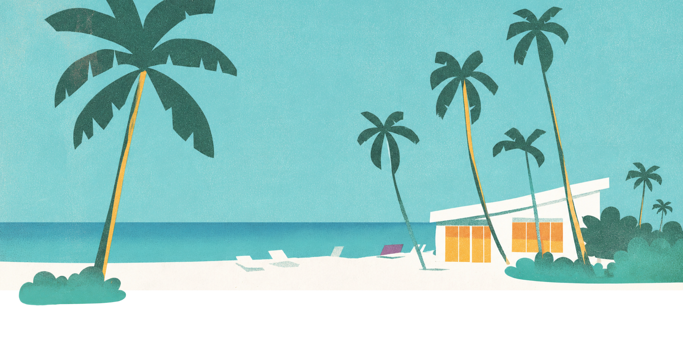
-BEACH VACATION-
PACKING LIST

CLOTHING | SWIM GEAR | TOILETRIES
- Shirts  - Tank Tops  - Pants/Shorts  - Dresses/Skirts  - Pajamas  - Socks & Underwear  - Sweatshirt  - Light Jacket  - Sandals/Shoes  - Sunglasses | - Swimsuits  - Cover-Ups  - Rash Guard  - Water Shoes  - Swim Diapers  - Goggles  - Water Toys/Balls  - Swim Vest/Jacket  - Swim Floats/Tubes  - Dry Clothes | - Deodorant  - Hairbrush/Comb  - Toothbrush  - Toothpaste  - Shampoo  - Razor  - Makeup  - Lip Balm  - Sunscreen  - Soap/Body Wash
BEACH DAYS | FOOD & DRINKS | EXTRAS
- Beach Bag  - Beach Towels  - Sun Hat  - Beach Chairs  - Beach Umbrella  - Towel Clips  - Sand Toys  - Beach Tent/Shade  - Portable Safe  - Snorkel Gear | - Water Bottles  - Cooler  - Ice Packs  - Wet Wipes  - Trash Bag  - Snacks  - Drink Mixes  - Plastic Bags  - Cash  - Hand Sanitizer | - Chargers  - Anti-Itch Cream  - Personal Fan  - Aloe Vera  - First Aid Kit/Medicine  - Cell Phone Case  - Hotel/Rental Details  - Waterproof Bag  - Book/Kindle

