Ursula Gutmann  Mobile Developer  Mobile Developers know how to create software and user experiences tailored to their employer’s or client’s needs. They have to know all parts of this process by heart – coding, testing, debugging, documenting and potentially even know how to apply it across. |  |  | 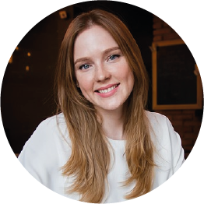
 | + 1 425-418-9283 |  | mail@domain.ltd |  | 39 Bechtel Points,Bahringerport |  | @linkedin.com

Work experience
10/2016 - 2/2019  Milan, Italy | Design, Build and Market of Mobile Apps  - I have currently 2 applications that have more than 5'000.  - Language used: Java for Android and Swift for Apple.  - Creation of VM, Server roles configuration.  - Administration of Active Directory, SCCM and FS access.
10/2019 - 3/2020  Milan, Italy | IT Technical Consultant  - Creation of VM, Server roles configuration.  - Administration of Active Directory, SCCM and FS access.  - Troubleshooting.
10/2020 - 3/2021  Milan, Italy | Junior System Administrator  - Creation of VM, Server roles configuration.  - Administration of Active Directory, SCCM and FS access.  - Troubleshooting.  - I have currently published 2 applications that have more than 5'000 daily users..

Education
2015 - 2016,  Crema, Italy | Security Systems and Computer Networks,  University of Milan

Organisational / Communication skills
Always on time Analytics Decision making Loyalty Open minded Sense of humour

Skills
Windows System | Java | Meraki | IIS
Windows Server | VM Ware | Android Studio | Kali linux

