x
A minimalist city digest focused on culture, community, and modern living. |  |  |  | Issue #12 | July 27, 2028
URBAN ECHO
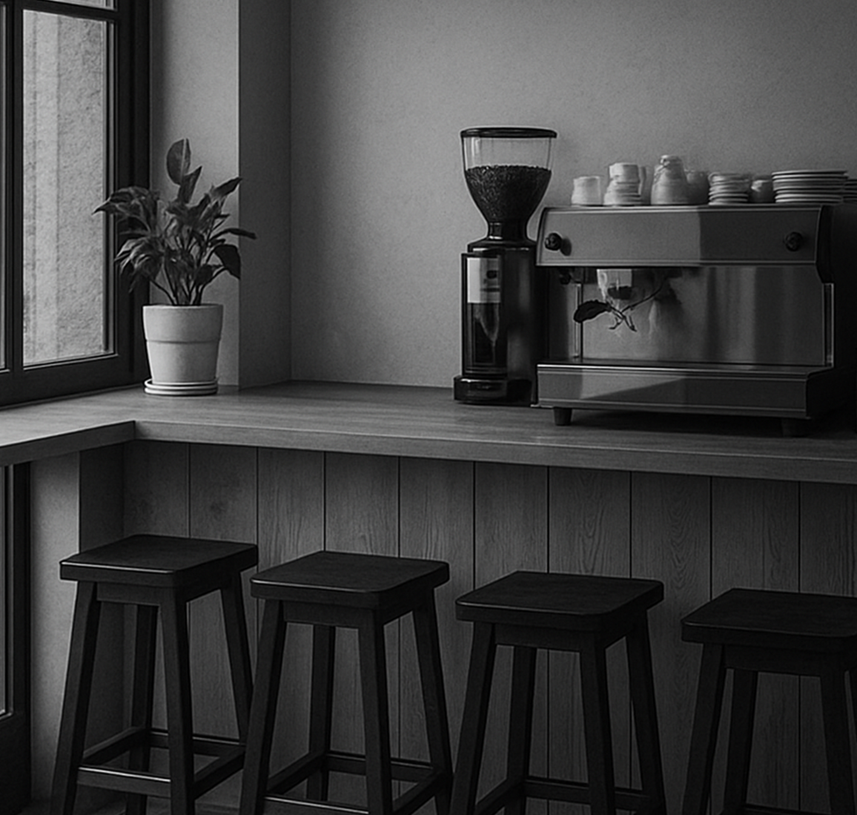  Photographer: William Harper. |  |  |  | VERTICAL  GARDENS  Green walls bring life to concrete  neighborhoods.  Vertical gardens are turning grey city walls into living, breathing canvases. These installations, made of climbing plants or modular greenery, are improving air quality and adding a splash of nature where trees can’t grow.  Architects and urban designers are experimenting with different plants that thrive in vertical conditions, from ferns to herbs. Some projects even allow residents to pick fresh mint or basil directly from the walls. The trend has gained momentum thanks to eco-conscious values and various government-led initiatives worldwide.  Passersby often stop to photograph these living walls, which have become social media favorites. Beyond their visual appeal, they also help insulate buildings, reducing energy costs.
COFFEE CORNERS

Tiny cafés redefine urban social life.

Minimalist coffee shops are taking over street corners, offering more than just caffeine—they provide a space for connection and reflection. Often no larger than a living room, these cafés feel intimate and personal, attracting locals who value authenticity.  The trend began as a reaction. |  | Customers enjoy sitting at communal tables, where conversations with strangers feel natural. These cafés often host small art displays or acoustic music nights, making them cultural micro-centers. The minimalist design—wooden tables, neutral tones, and soft lighting—encourages focus.

A minimalist city digest focused on culture, community, and modern living. |  |  |  | Issue #12 | July 27, 2028
Customers enjoy sitting at communal tables, where conversations with strangers feel natural. These cafés often host small art displays or acoustic music nights, making them cultural micro-centers. The minimalist design—wooden tables, neutral tones, and soft lighting—encourages focus and calmness. It’s not unusual to see someone sketching, writing, or brainstorming. Despite their size, these cafés have a big impact on neighborhoods.

"It’s like the city’s heartbeat slows down and becomes calmer"

says Lara Bennett
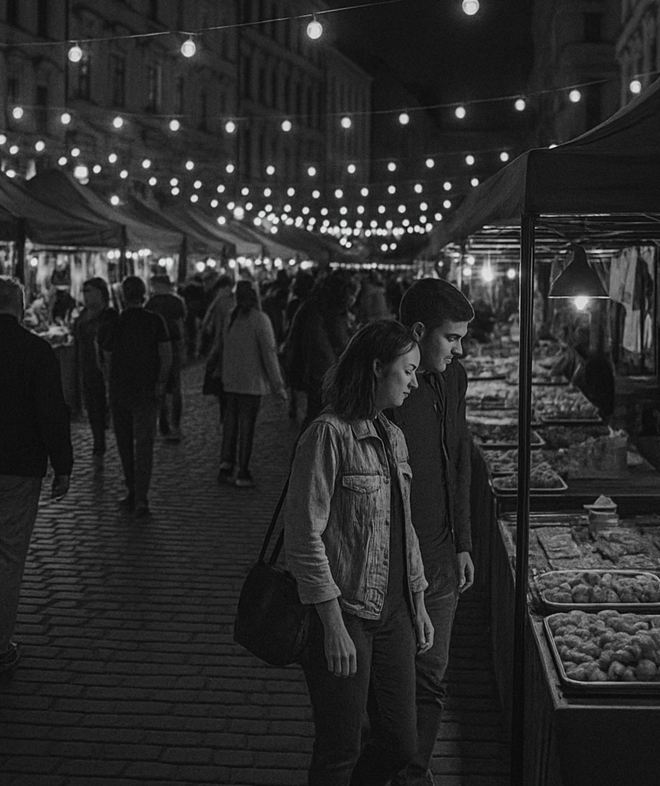

Photographer: William Harper.

NIGHT MARKET GLOW  Passengers describe this time as a pause before the night begins,  a way to mentally prepare for work or study. |  |  |  | These events are not just about commerce—they build a sense of community. Neighbors meet, tourists mingle with locals, and the atmosphere feels both festive and intimate. The warm lighting and the aroma of fresh food create an inviting environment. People are encouraged to sit, talk, and enjoy, instead of rushing.  These events are not just about commerce— they build a sense of community. Neighbors meet, tourists mingle with locals.
The revival of night markets has brought a new pulse to the city’s forgotten squares. These markets, filled with string lights and colorful stalls, attract families, artists, and food lovers long after sunset concept blends tradition with modern urban culture, featuring street food, handmade crafts, and live music. Vendors take pride in offering |  | The concept blends tradition with modern urban culture, featuring street food, handmade crafts, and live music. Vendors take pride in offering something unique, often inspired by local recipes and heritage. Despite their size, these cafés have a big impact on neighborhoods. Many residents claim that a cozy coffee corner feels essential.

A minimalist city digest focused on culture, community, and modern living. |  |  |  | Issue #12 | July 27, 2028
THE STEPS  Minimal traffic zones highlight  the beauty of walking.  Car-free zones are changing how we experience the city. With fewer vehicles, streets feel safer, cleaner, and surprisingly alive. The soundscape changes—footsteps, laughter, and street musicians replace engine noise. Walking becomes a pleasure rather than a necessity. People slow down, look around, and notice details they would otherwise miss.  Car-free zones are changing how we experience the city. With fewer vehicles, streets feel safer, cleaner, and surprisingly alive. |  | 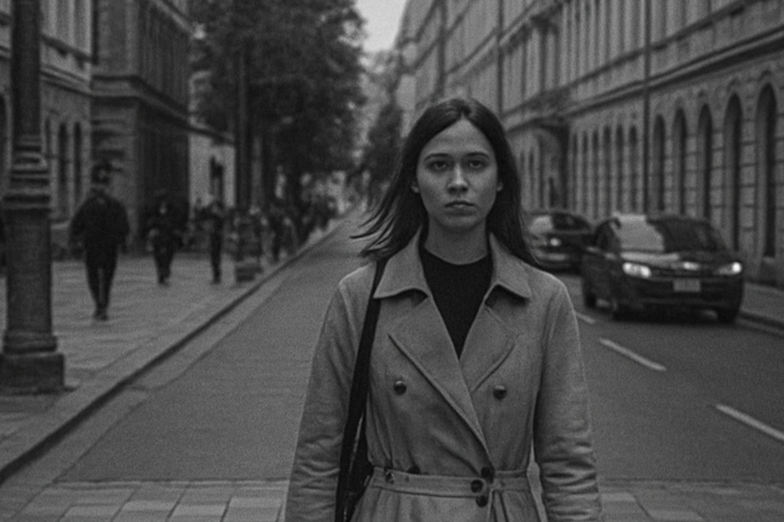  Photographer: William Harper.
 |  | Shops and small restaurants report higher foot traffic, as visitors enjoy exploring without the rush of traffic lights or crowded parking spaces.  Despite their size, these cafés have a big impact. |  | Urban planners are expanding these zones, inspired by European cities where pedestrian streets have long been a cultural norm. Despite their size, these cafés have a big impact on local communities.
THE MORNING TRAM  City commuters embrace quiet moments on the rails. |  |  |  | Minimalist coffee shops are taking over street corners, offering more than just caffeine—they provide a space for connection and reflection. Often no larger than a living room, these cafés feel intimate and personal, attracting locals who value authenticity. The trend began as a reaction to large, impersonal coffee chains. Small café owners focus on quality beans, careful brewing, and a design that reflects simplicity.
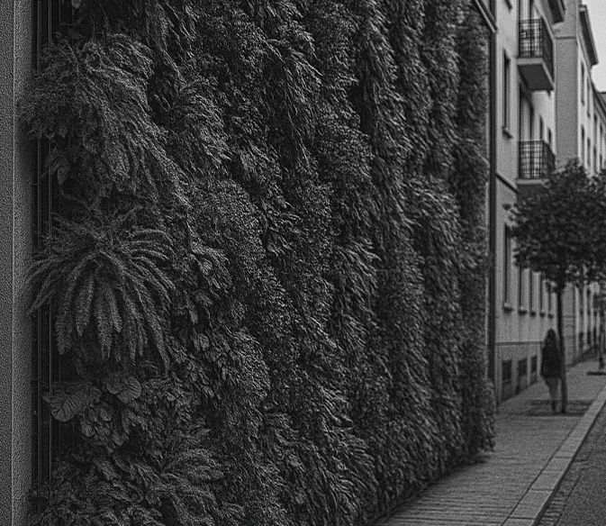  Photographer: William Harper. |  | Minimalist coffee shops are taking over street corners, offering more than just caffeine—they provide a space for connection and reflection. Often no larger than a living room, these cafés feel intimate and personal, attracting locals who value authenticity.  The trend began as a reaction to rapid urban growth.

A minimalist city digest focused on culture, community, and modern living. |  |  |  | Issue #12 | July 27, 2028
THE MORNING TRAM  Passengers describe this time as a pause before the day begins,  a way to mentally prepare for work or study. |  |  |  | 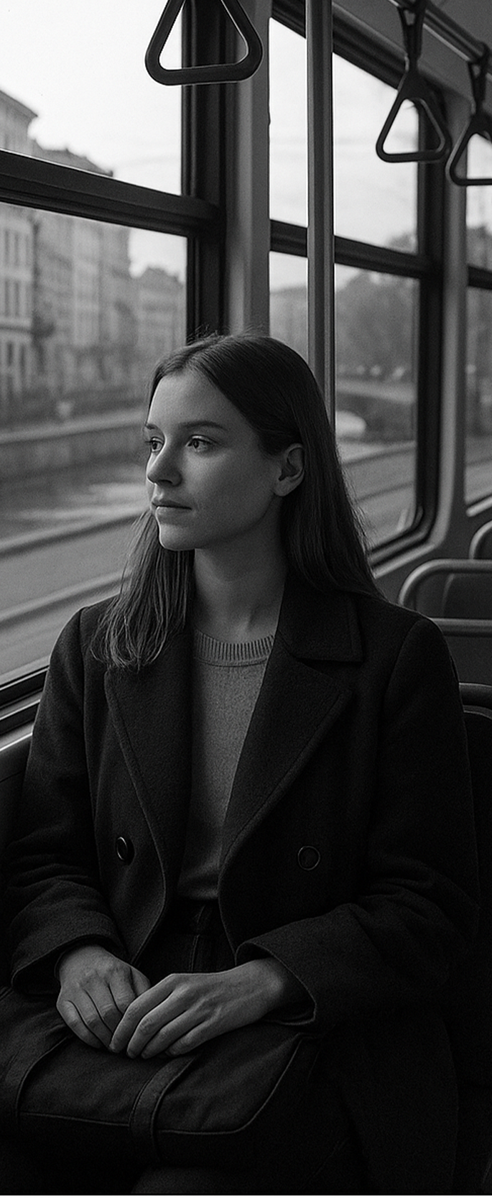  Photographer: William Harper.
The early tram has become more than just transportation; it’s a quiet ritual for many city residents. As the sun rises, the empty streets offer a rare view of the city waking up slowly, bathed in golden light. The tram glides almost silently, creating an atmosphere of calm that contrasts with the usual urban chaos.  Passengers describe this time as a pause before the day begins, a way to mentally prepare for work or study. |  | City planners have noticed an increase in public transport use during off-peak hours, suggesting that more people appreciate this slower start. Some companies even promote flexible schedules, allowing employees to take early trams for a calmer commute.  "There’s something peaceful about watching the city wake up while the tram hums through empty streets"  Says Lara Bennett
GREEN WALLS BRING  Architects and urban designers are experimenting with different plants    Photographer: William Harper. |  |  |  | Minimalist coffee shops are taking over street corners, offering more than just caffeine—they provide a space for connection and reflection. Often no larger than a living room, these cafés feel intimate and personal, attracting locals who value authenticity.  The trend began as a reaction to large, impersonal coffee chains. Small café owners focus on quality beans, careful brewing, and a design simplicity and warmth.

